Chapter 5

Causal representation

In this chapter a method of representing causal relations extracted from texts documents is presented. This representation algorithm is based on several standard methods of knowledge representation such as knowledge maps, causal maps, and McCulloch-Pitts cells, previously explained in Chapter 2 Causality, Natural Language, Information Retrieval and Fuzzy Logic. This chapter is divided in three main parts:
- The first part reviews the concepts and methodologies used to represent the information obtained in the previous chapter. The theoretical bases as well as some examples of illustrating it are explained.
- The second part shows the full process of extraction, summarization and representation for two different examples, both related with medicine. The first one is related with the field of gynecology, and the input concept to dispatch the process is pulmonary hypoplasia. The second example comes from the field of oncology and tries to find the relationship between smoking and lung cancer.
- The third part proposes a fuzzy interpretation of a causal graph based on Kosko’s model [Kosko1986]. The causal graph obtained in the previous step is presented, and the causality that every node imparts to the adjacent one is calculated.
5.1 Basis for a causal representation
This process translates the causal summaries extracted from the processed sentences into a causal graph. One of the primary goals to achieve is to maintain the amount of information retrieved, that is, do not lose information during the representation phase, because it may affect or change the causal relationships. The standard algorithms used to represent causal information are not based on very complex examples, linguistically speaking, that is why they do not take into account aspects such as the location or modifiers that, depending on the sentence can be rather important.

As mentioned in chapter 2 Causality, Natural Language, Information Retrieval and Fuzzy Logic, there are specific methods of representing causal relationships. One variety, the Cognitive Maps, are those that show the structure of argument and conclusion: these types of maps show the logic behind conclusions and decisions to act. Causal beliefs are included, to show the impact of varied evidence and the links between chains of reasoning. So these types of maps, able to create chains of reasoning, are suitable for the representation of the retrieved relationships. The problem is that in this representation, the path that it is defined does not allow for the representation of all the information retrieved. So the decision was made to use these maps as basis, and add some other influences from other types of representations.

The first models to study are the Conceptual Graphs, which are a system of logic based on the existential graphs of Charles Sanders Peirce [Peirce1885] and the Semantic Networks of the Artificial Intelligence. According to J. F. Sowa, this model of representation “.express meaning in a form that is logically precise, humanly readable, and computationally tractable. With a direct mapping to language, conceptual graphs serve as an intermediate language for translating computer-oriented formalisms to and from natural languages”. So this model with its graphic representation is a readable but formal design suitable to represent linguistic relationships. It has been implemented in a variety of projects for Artificial Intelligence such as database design, Expert Systems, and Natural Language Processing.
On these graphs, concepts are represented by rectangles, and conceptual relations are represented by circles or ovals (using the display form, there are other types of notations). For instance, if the sentence to be represented is John is going to Boston by bus, the conceptual graph obtained would be as shown in fig. 5.1. With this model a normal sentence with modifiers of location and intensity may turn into a complex representation, with many intermediate nodes (in the case of fig. 5.1 there are three intermediate nodes even though it is a simple sentence). For this reason, the causal summaries were not represented using this model, despite the fact that it provided some good ideas in its final representation, like for example preposition representation (by, in, on, etc.).

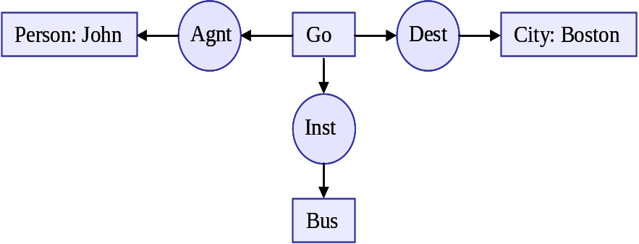
Figure 5.1: Conceptual map of the sentence John is going to Boston by bus.

To represent the nodes in the causal relationships the McCulloch-Pitts cells have served as inspiration [McCulloch1943]. The McCulloch-Pitts neuron was first proposed in 1943 by Warren McCulloch and Walter Pitts, a psychologist and a mathematician, in a paper illustrating how simple artificial representations of neurons could in principle represent any arithmetic function. The McCulloch-Pitts neuron can easily be understood as a simple mathematical operation. This operation has several inputs and one output which performs two elementary operations on the inputs: first it makes a weighted sum of all the inputs, and then it applies a functional transform to that sum which will be sent to the output. If there are N inputs {x₁, x₂, ... , x_{n}}, or an input vector X, the output y can be expressed as a function of its inputs using to the following equations:
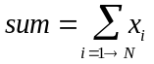 (1)
and
y = f(sum) (2)

The transfer function f() in its most simple form is just a threshold function giving an output of unity when the sum exceeds a certain value, and zero when the sum is below this value. It is common practice in neural networks to use the sigmoid function as the transfer function, which can be expressed as:
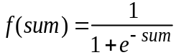 (3)

Points (1), (2) and (3) illustrate the basic operations of a McCulloch-Pitts neuron. It is common practice to apply an appropriate scaling to the inputs (usually either 0 < xi < 1, or -1 < xi < 1).

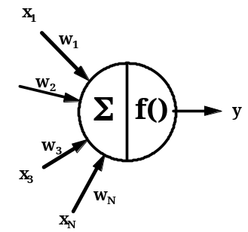
Figure 5.2: The McCulloch-Pitts artificial neuron as a mathematical operation.

This frame allows the management of uncertainty or vagueness associated with nodes or edges in a graph. McCulloch-Pitts cells permits also to weight the effect with a value; in order to obtain a flexible description of the effect or a flexible conclusion.
The fuzzy mechanism used as a basis is the one presented by B. Kosko [Kosko1986]. This model is also inspired by Axelrod’s cognitive maps [Axelrod1976].

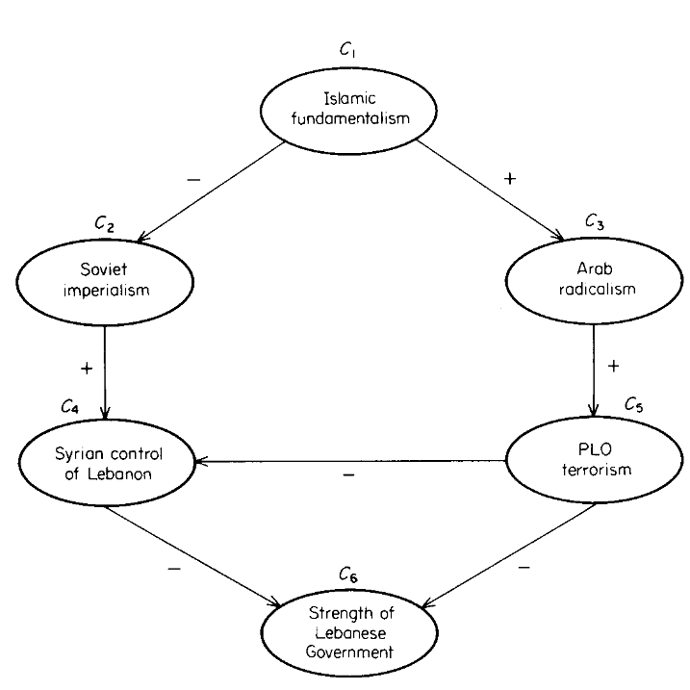
Figure 5.3: Axelrod’s example of cognitive map [Axelrod1976].

A cognitive map, is a signed diagraph where nodes are variable concepts (like social instability), and edges are causal connections. A positive edge from one node A to node B, means that A causally increases B. On the other hand, a negative edge from A to B, means that A causally decreases B. Through the adjacency matrix, in these graphs it is possible to know the causality that a node imparts to others, being 0 in the case that both nodes are not linked, -1 if the cause node decreases the effect node, or 1 if the cause node increases the effect node.

Causality is more complex than positive or negative values. It permits degrees that make for imperfect and vague causal relationships, like much, little, a lot, usually, sometimes, etc. Fuzzy Cognitive Maps take these fuzzy quantifiers and modifiers into account.

The representation of causality is not trivial. It is more complicated than logical implication because A→B is replaceable by ¬B→¬A, but in a real example, if smoking implies lung cancer, not having lung cancer does not necessarily imply a lack of smoking. That is why Kosko sees causal relationships as a correlation between A and B. If A causes B, then increasing A increases B, and decreasing A, decreases B. The inverse relationship would be a negative correlation. If A causally decreases B, then increasing A, decreases B, and decreasing A increases B.

This behaviour can be represented in a fuzzy set framework, where causal concepts are variable concepts belonging to a fuzzy subset of some concept space, where the change in fuzzy-set member degree represents concept variation. So a concept C_{i} is defined as the fuzzy union (disjunction) of some fuzzy quantity set Q_{i}, and the associated dis-quantity set ~Q_{i}, C_{i} = Q_{i} ∪ ~Q_{i}.

Fuzzy causality can be defined in terms of logical relationships among fuzzy concepts. So let C_{i} and C_{j} be two causally related concepts. C_{i} causally increases C_{j} (positive causality) if (Q_{i}∩M_{i}) ⊂ (Q_{j}∩M_{j}) & (¬Q_{i}∩M_{i}) ⊂ (¬Q_{j}∩M_{j}), and C_{i} causally decreases C_{j} if (Q_{j}∩M_{i}) ⊂ (¬ Q_{j}∩M_{j}) & (¬ Q_{i}∩M_{i}) ⊂ (Q_{j}∩M_{j}), where C_{i}, C_{j} are concepts; Q_{i}, Q_{j} are fuzzy quantity sets, and M_{i}, M_{j} are the modifiers of C_{i} and C_{j}. In the case of negative causality, it can be defined with the same fuzzy quantities and relationships as positive causality, so every node can be replaced as:
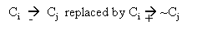
So, negative causality can be removed, and the negatives relationships transformed into positives as for example in the relationship displayed in figure 5.4:

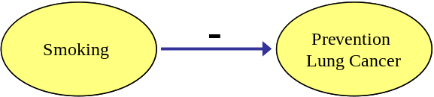
Figure 5.4: Example of negative relationship.
Could be transformed into:

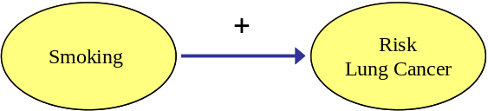
Figure 5.5: Example of a positive relationship.

Kosko also proposes a fuzzy causal algebra for causal propagation and causal combination on a fuzzy causal map. Therefore, a causal path linking nodes C_{i} and C_{j} through C_{i}→C_{k1}→C_{k2}→C_{k3}…→C_{kn} →C_{j}. He defines the indirect effect, as the causality that a given node C_{i} imparts to another node C_{j} linked by a causal path (that is, the degree of subsethood of C_{i} in C_{j}). The total effect of C_{i} on C_{j} is all the indirect-effect causality that C_{i} imparts to C_{j}, so if there is only one causal path from C_{i} to C_{j}, the total effect is equal to the indirect effect.

At this point, and due to the fact that causality is fuzzy, it permits vague degrees expressed by vague quantifiers or linguistic edges such as always, partially, sometimes, usually, very little, etc, so it is possible to establish a partially ordered P of causal values. According to Kosko, the simplest abstract operations are achieved by interpreting the indirect-effect operator I as a minimum operator, and the total effect operator T as a maximum operator. So the indirect effect amounts to specifying the weakest causal link in a path, and the total effect operation amounts to specifying the strongest of the weakest links:
I₁(C₁,C₅) = min {e₁₃, e₃₅} = min {much, a lot}= much
T(C₁,C₅) = max {I₁(C₁,C₅), I₂(C₁,C₅) , I₃(C₁,C₅) }
= max {much, some}= much
5.1.1. Representation model for causal and conditional sentences.
The representation model presented in this section gathers together many aspects of the ones described in chapter 2 Causality, Natural Language, Information Retrieval and Fuzzy Logic and in this chapter. These models have been adapted in order to produce one able to hold a large part of the information retrieved without losing important significance.

As it has been said, the nodes are based on McCulloch-Pitts cells. These cells have been modified to contain the modifiers associated with a node and retrieved by the program, that are those concerning a location (denoted by the prepositions in, at, on, around, etc.), intensity (more, less, low, high, much, many, more, severe, etc.), and specification of the node (by, with, such as, etc.). For this purpose a new cell divided into two parts has been created. The upper part contains the name of the cell (or node) and the threshold or intensity of the global cell (this intensity value affects the whole cell, independently of the fact that there may exist other values affecting the cell modifiers). The lower part of the cell is divided into two parts. The left part is used to express location, and the right part to contain the node modifiers that indicate specification. These two blocks can be affected by intensity quantifiers too.

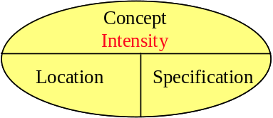
Figure 5.6: Graphical representation of a node with its modifiers.

For example if the node to be represented is severe pulmonary hypoplasia with many oligohydramnios, the node name would be pulmonary hypoplasia; the intensity of the node would be severe, marked in a different colour to denote this; and the node specification would be oligohydramnios, also modified by the intensity quantifier many, marked in a different colour. So the representation of this node would be:

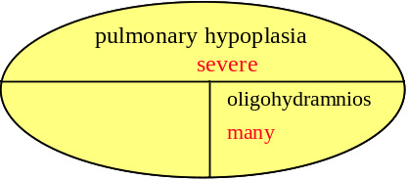
Figure 5.7: Node representation of pulmonary hypoplasia with many oligohydramnios.

The relationships between nodes can be simple or compound. The simple relationships have the type of causal or conditional conjunction that link the two nodes. If the relationship has modifiers, they are also included in the link, but on the opposite side of it, marked in another colour, as in the example in the majority of cases neonatal death is due to pulmonary hypoplasia, which would be represented as follows:

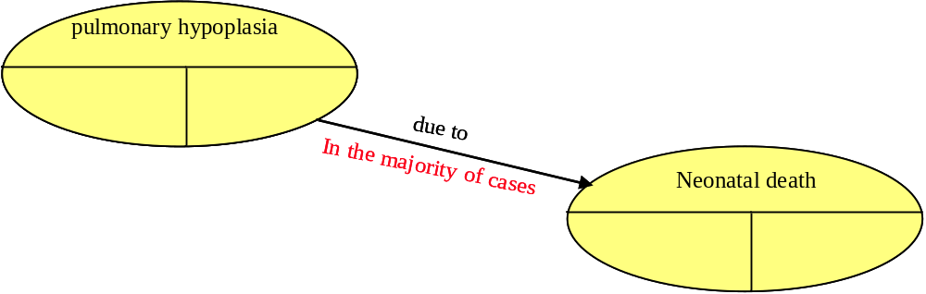
Figure 5.8: Representation of the sentence “in the majority of cases neonatal death is due to pulmonary hypoplasia”.

Compound relationships are linked by the conjunctions and/or. To represent them, the two nodes linked point at a square which indicated the type of link. The arrows are also different to indicate that there are not causal relationships. The arrow linking the square with the affected node is in these cases the causal one. For example, if the part of sentence to be represented is pulmonary hypoplasia due to multicystic kidneys or obstructive uropathy, the graph would be:

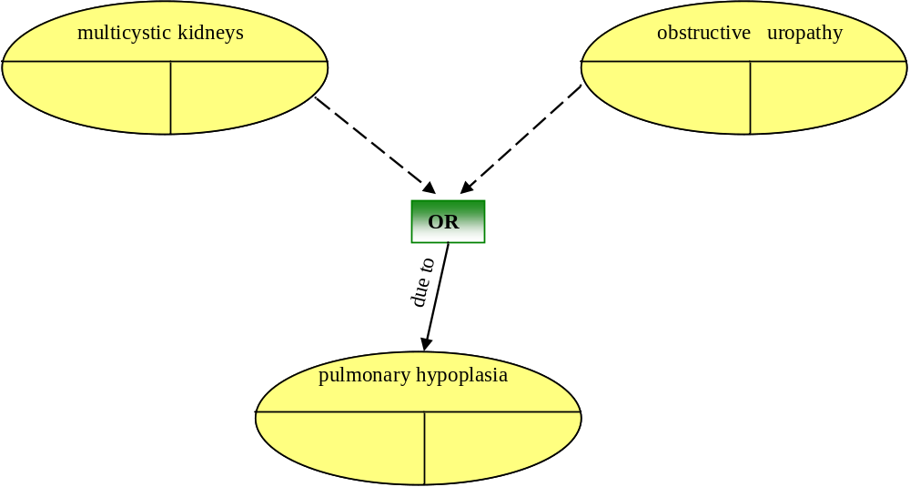
Figure 5.9: Representation of pulmonary hypoplasia due to multicystic kidneys or obstructive uropathy.

If the relationship is a reference to the node in general, the arrow will point the external oval to indicate that affects the whole node. Otherwise if the relationship affects any of the node modifiers, the arrow will enter the node pointing at the modifier that specifies that relationship. For example, in the sentence Fraser syndrome is almost always lethal due to the bilateral renal agenesis and laryngeal atresia, the arrow would point at lethal in the Fraser syndrome node as seen in this graph representation:
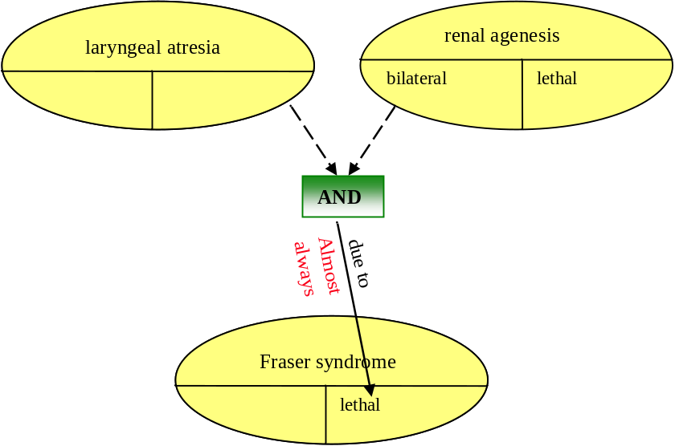
Figure 5.10: Representation of the sentence Fraser syndrome is almost always lethal due to the bilateral renal agenesis and laryngeal atresia.

5.2 Test I: Emulating a Q/A system
To test the process, the behavior of this method in a Q/A system has been emulated. The medical language is quite structured, so it simplifies its automatic processing, and is a domain which has practical interest. Two experiments to emulate how the process would respond in a semi-real situation have been designed. The first experiment formulates and process a query, isolates the sought concept and looks for it into a knowledge base. Five medical books related to gynecology have been chosen, to test the experiments.

The first part of the process consisted of the detection and analysis of conditional and causal sentences. The program returned the following results related to the number of conditional sentences retrieved and rejected.

Figure 5.11: Report of sentences retrieved and rejected.

Retrieving sentences such as:
-------------------------------------------------------------------------------------------------
>Line number:265 -- Certainly before 24 weeks and particularly in cases of associated spina bifida , the head circumference may be small rather than large for gestation.

**CLASIFICATION:IN CASE,IN CASE THAT, IN ORDER THAT. STRUCTURE 43
Modificador found: Certainly , intensidad: 5 , contex: .Certainly before 2 4
Modificador found: particularly , intensidad: 3 , contex: and particularly in cases of
Modificador found: rather , intensidad: 2 , contex: small rather than large for
-------------------------------------------------------------------------------------------------

Figure 5.12: Example of retrieved sentence.

It is also important to know the types of sentences retrieved, which belong to the 20 different patterns implemented, so the results obtained showed that the most typical patterns in these texts are type e24 (sentences with due to, or owing to) with 545 occurrences, followed by pattern e38 (phases with although, or even though) with 282 occurrences, and patterns e2 (belonging to the present simple) with 145.

Figure 5.13: Distribution of patterns in the classified sentences.

Pattern e38 is more related to conditionality than causality, as for example in the sentence Although there is concern that cases seen in early gestation may progress in severity, the lesion usually remains stable. On the other hand, patterns e24, and e2 are closer to causality because they do not leave any possibility for conjecture or doubt, as in the sentence (from the retrieved set), Supravalvar aortic stenosis can be due to one of three anatomic defects: a membrane (usually placed above the sinuses of Valsalva ), a localized narrowing of the ascending aorta (hourglass deformity) or a diffuse narrowing involving the aortic arch and branching arteries (tubular variety).These sets of patterns show that the text is written in a cause-effect form.

5.2.1. Processing the user’s query
Once the causal and conditional passages have been retrieved, the next step is the processing of the user’s query. There are many types of questions (see chapter 4, Summary process), for this experiment the semi-explicit question, What can be the results of pulmonary hypoplasia? is going to be emulated. The morphological analyzer would return the type of sentence as semi-explicit, due to the presence of the noun results, which could be considered as a synonym of are the effects, so the question could be re-formulated as What can the effects of pulmonary hypoplasia be? To locate what the user is asking for, it is necessary to find out the concept involved in the question. To do so, the query will have to be processed by the POST, returning the following set of tags:
What WP
can MD
be VB
the DT
results NNS
of IN
pulmonary JJ
hypoplasia NN
? SENT

Figure 5.14: POST exit for the query What can be the results of pulmonary hypoplasia?

This POST output will serve as input for the nominal sentence detection process. As has been explained, the process would locate as the nominal clause the pair adjective plus noun, JJ+NN, in this case pulmonary hypoplasia.
5.2.2. From the user’s query to the answer by means of a Causal Graph
This part of the process is in charge of the selection, processing and representation of those sentences related to the sought concept. There are cases, as in this example that the sought after concept has more than one word. In these cases the sentences where just one of these words is rejected as in the example The most common form of pulmonary stenosis is the valvar type due to the fusion of the pulmonary leaflets.

Once the query concept has been located, the concept search program will look inside of the conditional and causal set for those containing pulmonary hypoplasia, and will store them in a new file. The result of this process was the retrieval of 28 sentences, most of them belonging, except for three, to pattern e24 (due to). An extract of some of the retrieved sentences can be seen in figure 5.15.
In bilateral forms the prognosis is unfavorable in the majority of cases neonatal death is due to pulmonary hypoplasia as a consequence of the severe oligohydramnios.
Meckel Gruber syndrome is invariably lethal due to the severe pulmonary hypoplasia induced by the oligohydramnios.
Bilateral renal agenesis is always lethal due to the associated severe pulmonary hypoplasia.
Doppler studies in fetuses with pulmonary hypoplasia due to multicystic kidneys or obstructive uropathy reported increased impedance to flow in the branches of the pulmonary artery consistent with high peripheral pulmonary vascular resistance.

Figure 5.15: Example of retrieved sentences.

The concept graphing process will receive these 28 sentences as input, running the POST program and the parser to divide them into tokens. This token-lexeme output is processed again, locating the sought after concept inside a sentence and measuring the distance from the conditional or causal conjunction to evaluate whether or not both are in the same scope, and the arrow direction of the graph relationship. Once the algorithm has finished, the program will create a file with the graph schema.
For this example, the schema has been created with the sentences of fig. 5.15 due to the high number of nodes that the processing of the 28 sentences produced. The output file is as follows:
Node = pulmonary hypoplasia || associated modifyers: as consequence of severe oligohydramnios ----->> in majority of cases Node: = neonatal death //
Before node modifyer: severe Node = pulmonary hypoplasia associated modifyers: by oligohydramnios ----->> Gruber syndrome is invariably lethal //
Before node modifyer: severe Node = pulmonary hypoplasia ----->> renal agenesis is always lethal //
Node = pulmonary hypoplasia <<----- Node: multicystic kidneys or : obstructive uropathy //

Figure 5.16: Graph schema.

Once the graph schema has been built, the final representation has two possible options. The first one, more intuitive (in a causal format) would be separating the nodes antecedent of pulmonary hypoplasia, and the nodes created by the effect of pulmonary hypoplasia, as shown in figure 5.17:

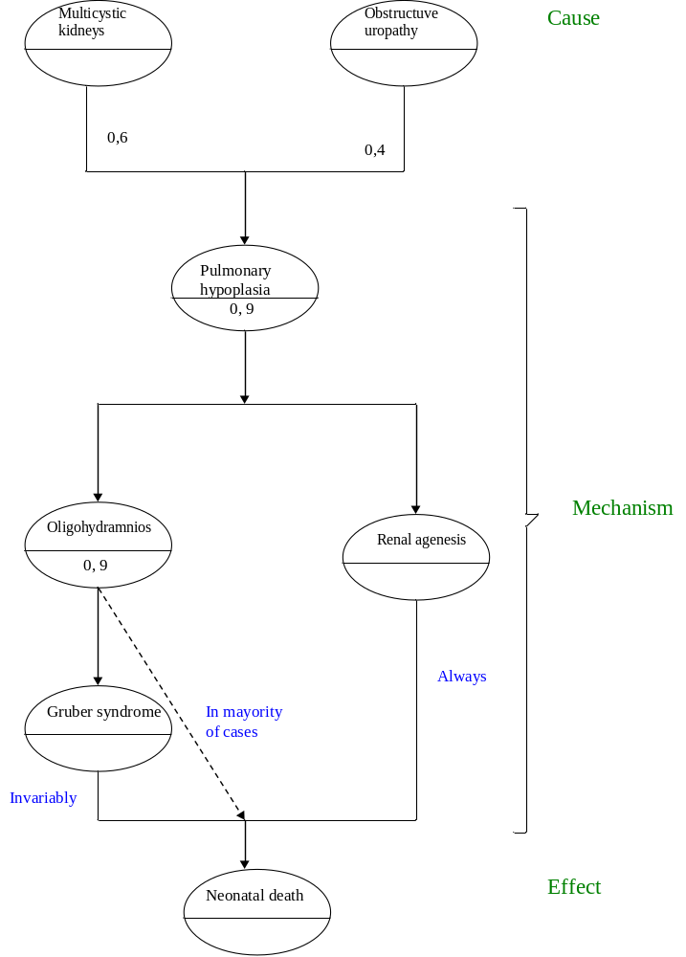
Figure 5.17: Graph representation for the concept pulmonary hypoplasia.
So, according to the graph shown, it is possible to formulate an interpretation of it, so the answer to the former question What can be the results of pulmonary hypoplasia?, would be: If pulmonary hypoplasia is severe, it may provoke renal agenesis, which is always lethal. Pulmonary hypoplasia also, as a consequence of severe oligohydramnios, provokes Gruber syndrome, which is invariably lethal. As a consequence of severe oligohydramnios, [pulmonary hypoplasia] causes in majority of cases, neonatal death.

The answer can also be formulated in a causal style: Severe pulmonary hypoplasia causes Gruber syndrome which is invariably lethal. Pulmonary hypoplasia also, caused by severe oligohydramnios, provokes Gruber syndrome, which is invariably lethal. As caused by severe oligohydramnios, pulmonary hypoplasia causes in majority of cases, neonatal death.

Causal graphs can be represented as McCulloch-Pitts cells. This frame permits the management of the uncertainty or vagueness associated with nodes or edges. In this example, the label severe can be represented, by a numerical threshold like 0,9. Fuzzy quantifiers like ‘in the majority of cases’ might indicate the intensity of the link. Therefore, the final effect could be labeled with a fuzzy value, functionally obtained from these input values and the appropriate definitions of fuzzy connectives. Therefore, suppose that SO (severe oligohydramnios) is caused by MK (multicysitic kidneys) or by OU (obstructive uropathy) and that the intensity of MK is 0,5 and the strength of OU is 0,95. Suppose that Oligohydramnios is severe when it exceeds the threshold 0.9. Because OU is 0,95, MK + OU cause SO. In order to maintain consistency, it has to be said that pulmonary hypoplasia (PH) is also severe if it exceeds the threshold 0,9. As the intensity of the node SO equals PH, the effect is propagated. No information is available about the intensity of the nodes ‘Gruber syndrome’ or ‘Renal agenesis’, so it is assumed that the cause is transmitted to the final node.

There is another question left: How many cases suffer this effect? It is needed to operate in an adequate way ‘In majority of cases’, ‘invariably’ and ‘always’. Let’s suppose that ‘In majority of cases’ represents about 80% of the cases and therefore, that it is reasonable to represent this linguistic quantifier with the degree 0,8. ‘Invariably’ and ‘always’, as do not admit exceptions, will be conveniently represented by 1. Pulmonary hypoplasia has the effect of ‘always death’ if Gruber syndrome or renal agenesis is developed, but only ‘death in the majority of cases’ if the disease follows an alternative path to these others. Therefore, it seems plausible to bet on the hope, to choose the minimum; that is: 0,8. Thus, making the inverse translation, the flexible answer would be In the majority of cases, pulmonary hypoplasia causes dead.

This representation is more intuitive and suitable to provide an automatic answer, but needs to be supervised. The method of representation proposed is less intuitive, but easier to be represented automatically by a specific program, because it does not need interpretation. The conclusions using this form of representation are basically the same, although in the former case they are more clearly represented, especially when managing the modifiers (such as severe oligohydramnios), as seen in figure 5.18.

This model of representation allows for more information and relationships than others because nodes and relationships can hold more information. It has been said that one of the main problems of the representation through graphs is that they usually become inefficient due to the high number of nodes required to represent a small piece of information. This model compacts the information and permits the integration of some nodes into others which are similar adding the specific information like modifiers or quantifiers.

Figure 5.18: Semi-automatic graph representation for the concept pulmonary hypoplasia.
This model can be easily expanded through each one of the nodes. For example, if the user wants more information about the relationship between pulmonary hypoplasia and renal agenesis, the process could perform a new search (from the global knowledge base), retrieving sentences like Fraser syndrome is almost always lethal due to the bilateral renal agenesis and laryngeal atresia, and Ultrasound examination is difficult because of the constant severe oligohydramnios due to renal agenesis, resulting in the following sentence schema:
Before node modifyer: bilateral Node = renal agenesis associated modifyers: and laryngeal atresia ----->> Node = Fraser syndrome is almost always lethal //
Before node modifyer: severe Node = oligohydramnios ----->> Node = renal agenesis //

Figure 5.19: Output schema of the aforementioned sentences.

These two sentences can expand and modify the existing graph, creating new nodes, and adding more information to the others:

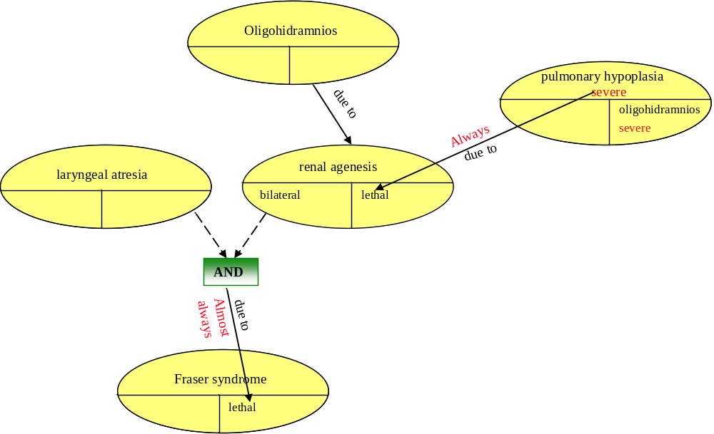
Figure 5.20: Part of the modified graph.

5.3 Test II: An application to a medical domain
This example establishes the relationship between two concepts such as smoking and lung cancer. The set of documents selected for this experiment were taken from the Mayo clinic web site, the American society for clinical oncology, the centers for disease control and prevention, and the sites e-medicine health, and lung cancer online.

The results of the detection and classification part of the process were quite good in part motivated by the language used in medical texts, which is more clear and concise than in other areas. The results are the following

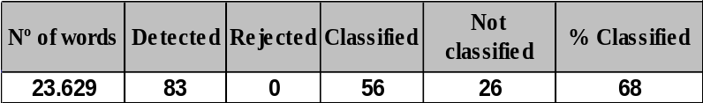
Figure 5.21: Report of sentences retrieved and rejected.

The distribution of patterns mainly belongs to pattern e2 (if + present simple + future simple), e3 (if + present simple + may/might) and e38 (although, even though), having a lower presence than the sentences with pattern e24 (due to), and with a higher variety of patterns than the former example (where most of the sentences were composed with pattern due to).

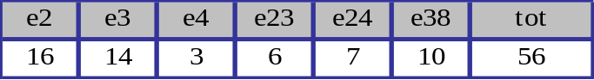
Figure 5.22 Pattern distributions.

The next part proceeded to the filtering of those sentences containing the words lung cancer or smoking. The system retrieved 82 sentences and 15 of them were selected to be represented in a medium size and, therefore, manageable graph. Some of the retrieved sentences were the following:
Sentences Retrieved
Every year, about 3.000 nonsmokers die from lung cancer due to secondhand smoke
In the united States, about 85% of lung cancer deaths are due to smoking
Your risk of lung cancer increases if you’re exposed to secondhand smoke
About 90% of lung cancers arise due to tobacco use
Exposure to the combination of radon gas and cigarette smoke provokes a greater risk for lung cancer than either factor alone.
Risk of lung cancer may be higher if a person's relatives have had lung cancer.
You are at much higher risk for lung cancer if you smoke cigarettes than a person who has never smoked.

Figure 5.23: Set of conditional and causal sentences retrieved.

Once the phrases have been selected, the POST and the Stanford parser have to divide the sentence in tokens. These types of patterns are mainly processed by the parser instead of the POST, because it is more suitable to establish the connection among tags and extract the components of the causal relation. In the previous example, most of the patterns belonged to type e24 (due to), which is better processed with the POST program instead of the parser. Despite this, the parser has also been programmed to hold these types of sentences, for example, in the case of the first sentence, the parser would retrieve:

det(year-2, Every-1)
nsubj(die-7, year-2)
quantmod(3.000-5, about-4)
num(nonsmokers-6, 3.000-5)
appos(year-2, nonsmokers-6)
nn(cancer-10, lung-9)
prep_from(die-7, cancer-10)
amod(smoke-14, secondhand-13)
prep_due_to(die-7, smoke-14)

Figure 5.24: Stanford parser output for the phrase “Every year, about 3.000 nonsmokers die from lung cancer due to secondhand smoke” (collapsed mode).

In this case the summary process would locate the tag due_to as the causal indicator. This tag associates the words die and smoking as belonging to the nodes effect and cause respectively. To create the two nodes, the process searches through the labels using the number associated with each word. For instance, to create the cause node, the algorithm would search through the tags the word smoke plus the number 14. If the tag is an adjective, adverb, or a modifier, as in this case amod (smoke-14, seconhand-13), the program would include this word in the node name. So the algorithm retrieves a brief schema of the useful information represented in a causal graph:
Node: secondhand smoke
----->> due to
Node: die lung cancer
Node intensity: about 3000 nonsmokers

Figure 5.25: Summary of the phrase “Every year, about 3.000 nonsmokers die from lung cancer due to secondhand smoke”.
Some of these sentences share the same antecedent or consequence node, as happened with risk lung cancer, which appeared several times. This node inherits all the modifiers that could appear within these sentences.

A relationship is specified by a modifier if the arrow is inside of the modifier cell, otherwise the arrow will be pointing at the border of the node. If the relationship has more than one modifier, the arrow will point to an intermediate node, aiming the arrows to the corresponding modifiers (like the relationships linked with and/or connectives).

The intensity of the relationship’s arrow (quantifiers), is marked in red, and the type of causal connective in black. As can be seen in the graph, there are four nodes with the word smoking, or something related, and another four with the words lung cancer. The rest of the nodes have been retrieved in the process. So with a graph like this, new relationships hidden at first sight could be established, for instance between smoking and fluid being accumulate around the lungs, to a certain degree, taking into account the quantifiers and qualifiers involved in every causal path.
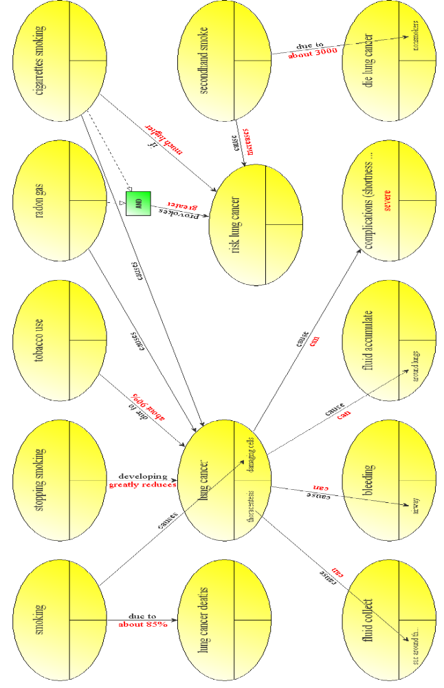
Figure 5.26: Causal graph establishing the relationship between smoking and lung cancer.
5.4 A Fuzzy approach of a semi-automatic Causal Graph
Taking the model proposed by Kosko as a reference [Kosko1986], and explained in section 5.1 Basis for a causal representation of this chapter, an example extracted from real sentences has been developed, to evaluate the causality that a given node imparts to others.

First the original graph (based in figure 5.26), has been normalized, so all the nodes like stopping smoking which introduce a decrement of the consequence have been modified, so the nodes are in terms of positive causality (A increments B).

To calculate the causality that one node imparts to others, the adjacency matrix is represented. In this case, A causally increases B if e_{ij} is equal to 1, A causally decreases B if e_{ij} is equal to -1, and A has no effect in B if e_{ij} is equal to 0 (in this case, A and B are not causally linked). So the adjacency matrix for the example proposed in figure 5.28 is:

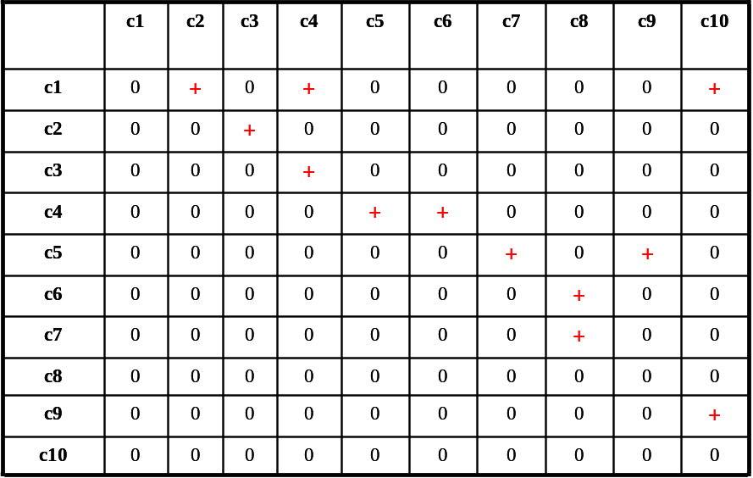
Figure 5.27: Adjacency matrix of the causal graph represented in figure 5.28.
In the original proposal, the relationship between smoking and lung cancer was studied. This graph created several nodes, as seen in figure 5.26, but the node Death was repeated very often (gathering together the nodes die lung cancer and lung cancer deaths). Linking these nodes there are several paths to each one of them with a different intensity.

To calculate the indirect effect and total effect from the node Smoking to the node Death, a partially ordered set with all the quantifiers and linguistic edges appearing in the graph has been established. The lowest of these values is eventually, being lower than can (which also introduces a degree of uncertainty), lower than about 85%, lower than 90% and lower than causes that would be the equivalent to 1. The set would be:
P = {eventually<can<about 85%<90%<provokes<=causes }

There are seven possible paths linking Smoking and Death, so the indirect effect of each path is (the number indicates the node):
I{n₁,n₂,n₃,n₄,n₆,n₈,n₁₀} = min{causes, causes, eventually, can, can, provokes} = eventually.
I{n₁,n₂,n₃,n₄,n₅,n₇,n₈,n₁₀} = min{causes, causes, eventually, can, causes, causes, provokes} = eventually.
I{n₁,n₂,n₃,n₄,n₅,n₉,n₁₀} = min{causes, causes, eventually, can, can, can} = eventually
I{n₁,n₄,n₆,n₈,n₁₀} = min{about 90%, can, can, provokes} = can.
I{n₁,n₄,n₅,n₇,n₈,n₁₀} = min{about 90%, can, causes, causes, provokes} = can.
I{n₁,n₄,n₅,n₉,n₁₀} = min{about 90%, can, can, can} = can.
I{n₁,n₁₀} = min{85%} = 85%.

So the total effect that the Smoking node has upon the Death node is the maximum of all the indirect effects, that is, the strongest of all the weakest links. In this example it would be:
T(n₁,n₁₀) = max ( I₁(n₁,n₂,n₃,n₄,n₆,n₈,n₁₀), I₂(n₁,n₂,n₃,n₄,n₅,n₇,n₈,n₁₀), I₃(n₁,n₂,n₃,n₄,n₅,n₉,n₁₀), I₄(n₁,n₄,n₆,n₈,n₁₀), I₅(n₁,n₄,n₅,n₇,n₈,n₁₀), I₆(n₁,n₄,n₅,n₉,n₁₀), I₇(n₁,n₁₀) ) = max (eventually, eventually, eventually, can, can, can, 85%) = 85%.

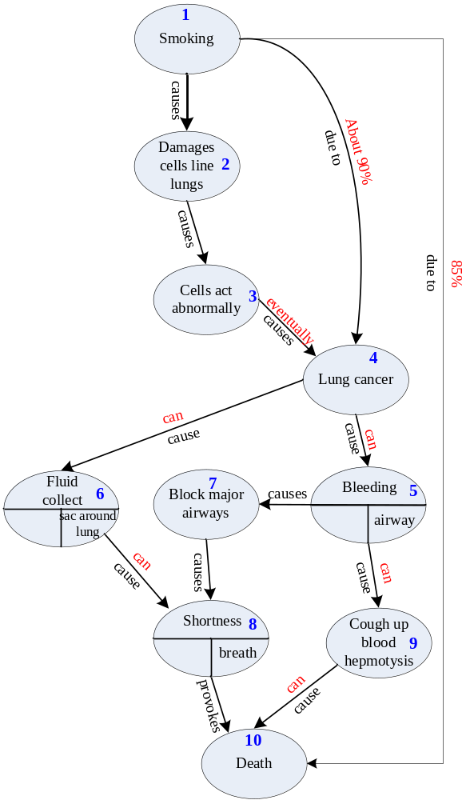
Figure 5.28: Causal graph to calculate the indirect and total effect between smoking and death.

As a result, the total effect between the node Smoking and the node Death is 85%, this is because all the output paths of the node n₄ are labeled with the linguistic edge can, which is one of the lowest in the partially ordered set, so it leaves the path with the most causal influence the one linking directly n₁ and n₁₀.

http://www.jfsowa.com/cg/index.htm
Paladini, D., Volpe, P. : Ultrasound of congenital fetal anomalies, differential diagnosis and prognostic indicators.Informa healthcare (2007). Pilu, G., Nicolaidesk, K. : Diagnosis of fetal abnormalities, the 12-23 weeks scan. Isoug & The Fetal Medicine Foundation, (2002).Nikolaidesk, K., Rizzo, G. : Doppler in obstetrics. The Fetal Medicine Foundation, (2002).Nikolaides, K. : The 11-13 weeks scan. The Fetal Medicine Foundation, (2002).Barbieri, R., Berga, S. :Precis: an update in Obstetrics & Gynecology. American College of Obstetricians and Gynaecologists, (2002).
http://www. mayoclinic.com
http://www.cancer.net/patient/Cancer+Types/Lung+Cancer/
http://www.cdc.gov/cancer/lung/basic_info/
http://www.emedicinehealth.com/lung_cancer/article_em.htm
http://www.lungcanceronline.org/info/index.html

